**GIT ON WINDOW MACHINE**

Hello, everyone this is continuation of [my-first-commit](https://github.com/ayulearn/my-first-commit) on git, in this file I demonstrate how git commit works on windows machine. If you follow all the steps of [README.md](https://github.com/ayulearn/my-first-commit/blob/main/README.md) of my repository [my-first-commit](https://github.com/ayulearn/my-first-commit) they also do the same what I’m going to demonstrate here, but here you will find more easy way of using git in window machine (git commands are same, but Instead of using Linux command I use GUI’s )

STEPS: -

1.For git initialization steps are same as [git beginning](https://github.com/ayulearn/git-begining)

*NOTE: - when you use ‘git init’ command it create a hidden folder name ‘.git’ inside the respective folder in all machines (window, Linux, mac). Don’t do anything with this folder*

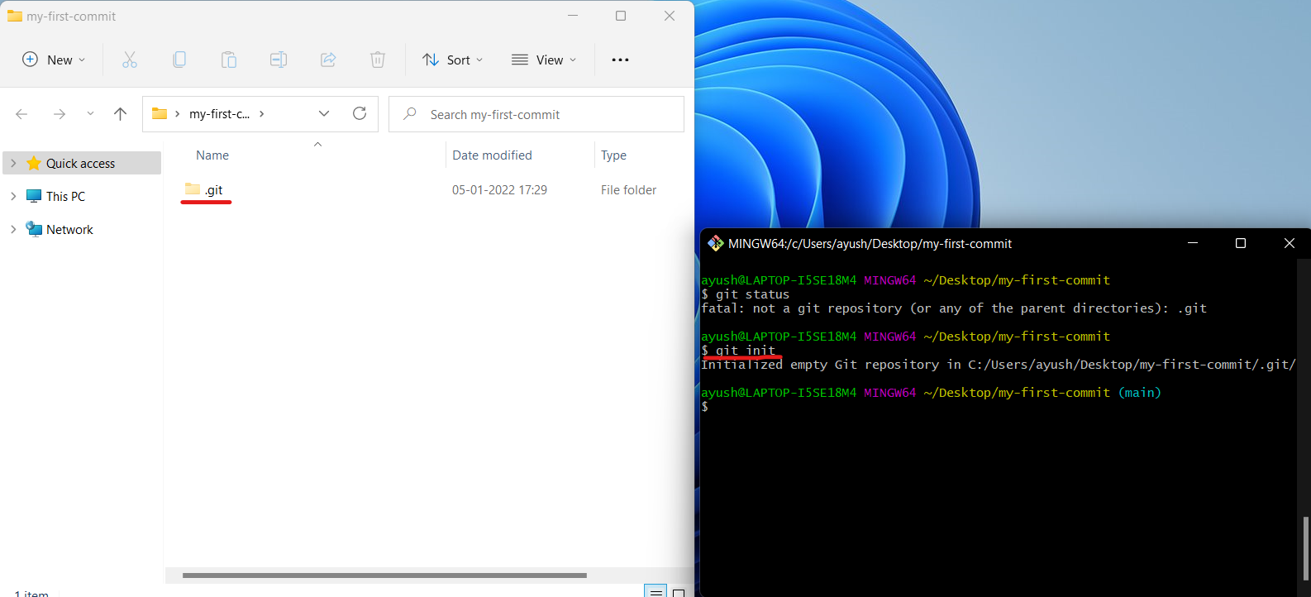

(In Linux use command “ls -al” to see ‘.git’ folder )

2. check status

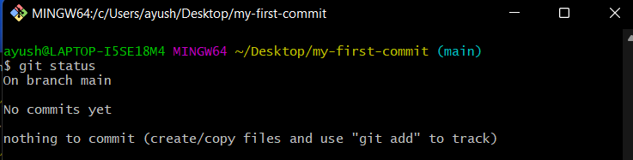

3. Now create a blank file in the folder name as “my first commit” (or whatever you want)

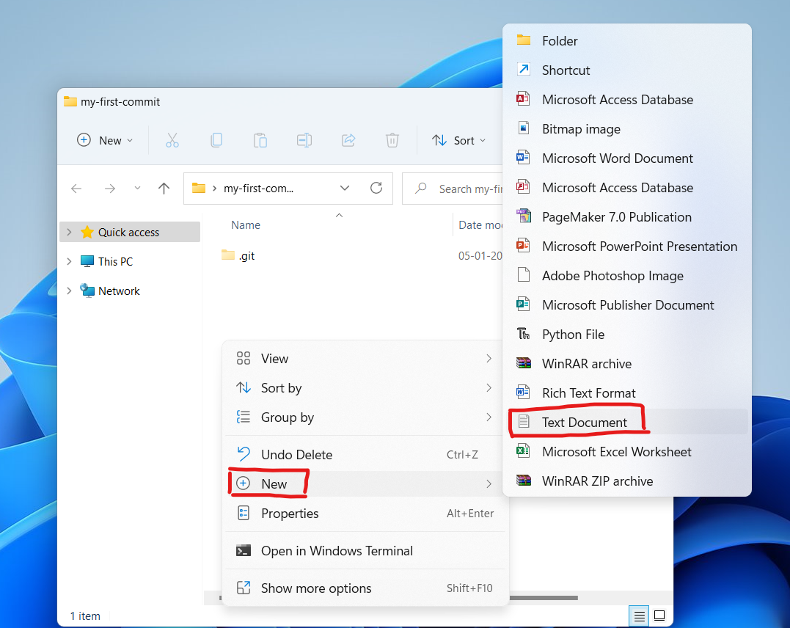

(In Linux we use “touch“ command to create file )

4. Now, check the status

git status

OUTPUT (file type shows ‘untracked files:’ observe it for now )

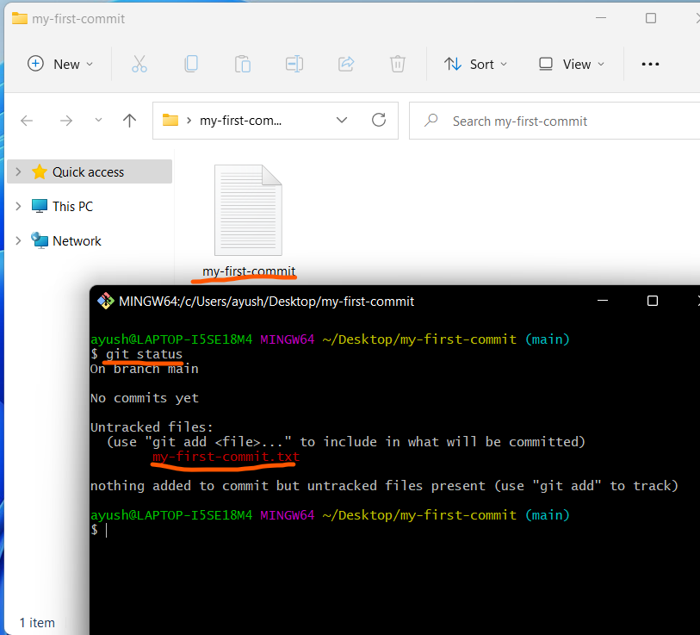

5. Add work to staging area

git add my-first-commit.txt

Then check status, Output:

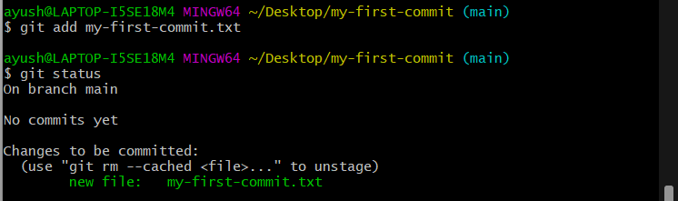

Now file name turns to green, it means file is on staging area

OPTIONAL: check log

git log

OUTPUT:



It means we haven’t made any commit yet

6. commit the work

git commit -m “my first commit”

Then check log, Output:

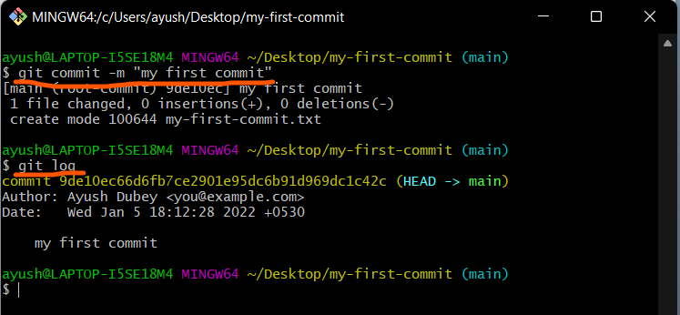

7. Now, open “my-first-commit.txt” on any text editor (I use Notepad)

Before do anything let’s check the status

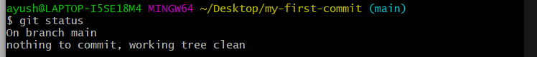

Now open the file and write whatever you want 😅 and save it

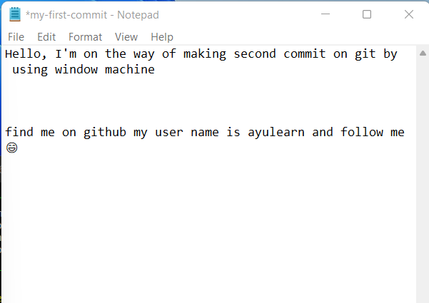

Now check the status

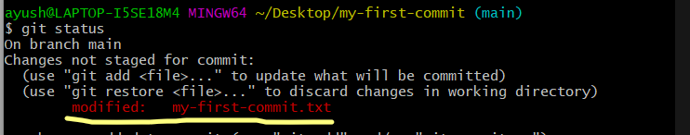

Go to step no.4 and Observe that this time Infront of file name “modified” word is written instead of new file and untracked files. It means now this file is tracked by git.

Point to be noted here is that whenever you change anything in the folder(my-first-commit) or in the file (my-first-commit.txt) even you insert a single space or delete a single dot or do anything and save it you have to commit every time in git.

Now to commit work you have to first add (step-5) then commit(step-6) with new message in double quote

Or you can follow this shortcut

*NOTE: remember this shortcut work only for modified and tracked file not for untrack file*

As usual first check the status first

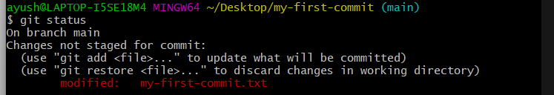

Since work is modified it means tracked by git so we can add and commit the work in a single command

git commit -a -m “add my github user name in my-first-commit.txt”

Or

git commit -am “add my github user name in my-first-commit.txt”

Output:-

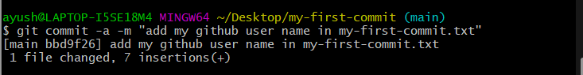

Check the status again

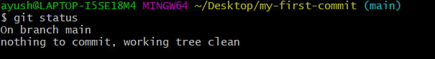

UPCOMMING TOPIC:

1. git branch
2. git switch/ git checkout
3. git merge
4. git clone
5. git pull
6. git remote
7. git push

and much more on git and github

hope this work is useful for you

you can follow me it is good for my portfolio

if you have doubt raise issue

my profile is [ayulearn](https://github.com/ayulearn/git-begining)